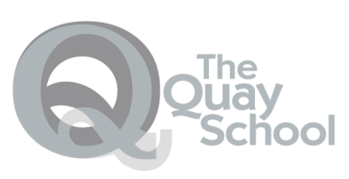
Pebble Lodge
Well Being + Medical
Curriculum, Individual Curriculum & Interventions. Rights Respecting School/School Council
Medical Interventions

YP are able to keep up with their Home School work.

AS, A2, GCSE, KS3 & BTec

NEET YP can re-engage

Literacy Functional Skills Level 1/2
Numeracy Functional Skills Level 1/2
Experience of CORE subjects
Educational Routine

Foundation Learning Qualifications
At Entry Levels/ Level 1 / Level 2

English and Maths
Food Technology
Art & Textiles
Life skills

School Timetable

KS5 – facilitated AS & A2 work provided by a YP own school

KS4 -

English GCSE/ Functional Skills Literacy
Maths GCSE/ Functional Skills Numeracy
AQA Science / GCSE
Humanities Project

Outcomes

Enrichment

AQA units in Food Technology
AQA units in Art

AQA units in Textiles

AQA units in subject related to student interest.

PSD/Life skills

PE / Recovery through Leisure (Education/Medical)

Those YP who are in education and follow this program will be better able to continue their studies upon leaving PL. Where YP are not accessing education, they are enabled to start new courses where appropriate.

