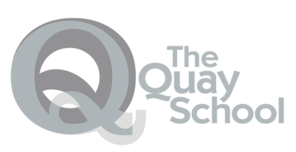
Harbourside KS3
Emotional Literacy
Is embedded within all curriculum tasks, alongside Emotional Literacy and Talkabout sessions.
Core Offer
On-site Education

Students joining Key Stage 3 at Harbourside undertake two induction sessions, to support planning for their needs.

Key Stage Three students follow a curriculum linked to the National Curriculum including:

English and Maths (2 lessons per week)
Topic studies (Humanities. RE and Science) (5 lessons per week)
PSHE
Emotional Literacy
Creative Art & Design
+ personalized learning and/or additional support with English/ Maths/ ELSA as required.

Outcomes
Core Offer
Off- site Education:
Students undertake two days of off- site learning, to support the development of a wider range of skills to support their personal and social development.
The days include one day taking part in Adventure Learning and another working towards an ASDAN qualification

Functional Skills Qualification in English and Maths

Successful transition to next stage of their educational journey.

AQA unit awards

ASDAN award (Bronze – Silver – Gold)

Students follow this pathway for differing lengths of time, with different start and end points. This pathway supports all students to be ready for a successful transition to their next educational placement.

