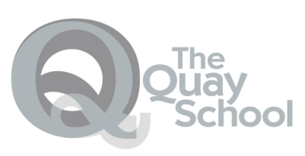
Parkstone
Groups 1 and 2 (years 10-11)
Option 1 (4 lessons a week)
Pupils choose one of the following options:
English Literature GCSE
Home Cooking BTEC
Art and Design GCSE

Option 2 (4 lessons a week)
Pupils choose one of the following options:
Photography GCSE
Psychology GCSE
Statistics GCSE
KS4 Formal

GCSEs in
English
Mathematics
Science (either Biology or Chemistry)
+ Option 1
+ Option 2
+ Level 1 PSD qualification

If pupils are in KS4 for more than one year, they will potentially be able to achieve 4 options

Group 3

Preparation for KS4
+ PSD qualification
+ Science Entry Level Qualification
+ AQA unit awards

All Pupils

Functional Skills in Literacy and Numeracy
Entry Level, Level 1 and Level 2.

Core Offer

All pupils

English (3 lessons a week)

Maths (3 lessons a week)

Science (3 lessons a week)

PSD (2 lessons a week)

Sport and Active Leisure (2 lessons a week)

Talkabout (1 lesson a week)

All Pupils have a key adult and access to pastoral support and academic interventions as necessary
Complementary Studies

Outcomes

Group 3 (years 7-10)
Preparation for GCSEs
Topic (3 lessons/wk)
Topic based learning covering: History, Geography and Religion, Philosophy & Ethics
Enrichment (2 lessons/wk)
Pupils study a variety of topics designed to give them access to leisure time activities or life skills they might not otherwise experience.
Life skills (1 lesson/wk)
Opportunities to develop life skills to support independence.
Functional skills 2 lesson/wk)
Literacy and numeracy

Learners will be supported in their transition from Group 3 to KS4 groups and on to further education, employment or training by guided mentoring and support from the school IAG worker.

