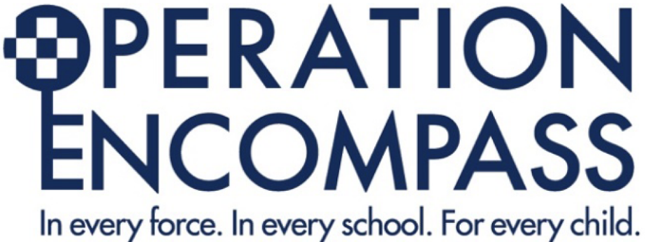

OUR KEY ADULTS ARE:
Headteacher: Russell Arnold
Deputy Headteacher: Vicki Glasgow
Assistant Headteacher, DSL & SENDCO: Lee Wilkins
Assistant Headteacher (Medical Provision): Helen Cottrell
Assistant Headteacher (Vocational Provision): Dan Beck
Assistant Headteacher (Short Stay School): Sharon Mallon
Assistant Headteacher (Hospital Provision): David Baleri

Operation Encompass Safeguarding Statement
Our school is part of Operation Encompass. This is a police and education early intervention safeguarding partnership which supports children and young people who experience Domestic Abuse.
Operation Encompass means that the police will share information about Domestic Abuse incidents with our school soon after they have been called to a domestic incident.
All Key Adults (DSL/DDSL) have attended an Operation Encompass local briefing as well as national online training.
Our parents are fully aware that we are an Operation Encompass school. The Operation Encompass information is stored in line with all other confidential safeguarding and child protection information.
The Key Adult has also led briefings for all school staff and Governors about Operation Encompass, the prevalence of Domestic Abuse and the impact of this abuse on children. We have also discussed how we can support our children following the Operation Encompass notification.
The Safeguarding Governor will report on Operation Encompass in the termly report to Governors. All information in anonymised for these reports. The Key Adult has used the Operation Encompass Toolkit to ensure that all appropriate actions have been taken by the school.

